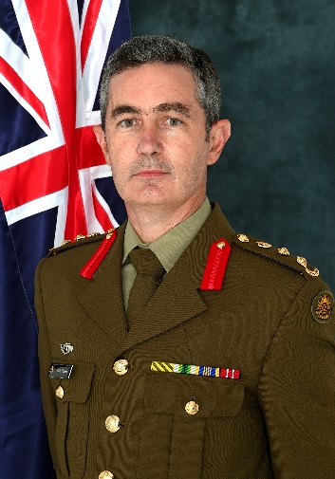
Biography – Colonel John Pearse, CSM
COL Pearse was raised on the family farm near St. Arnaud Victoria. He joined the Australian Army Reserve in 1998 undertaking officer training at Monash University Regiment while studying a Bachelor of Technology in Aviation at Swinburne University. He was commissioned into the Royal Australian Armoured Corps in 2001 completing his degree the same year.
COL Pearse completed the Tank Regimental Officer’s Basic Course and on completion was posted to 1st Armoured Regiment as the Reserve Troop Leader. He commanded his Troop independently at Puckapunyal building the Reserve capability as well as exercising his Troop with 1 Bde. In 2005 LTCOL Pearse spent eight weeks in California with 1st Tank Battalion, United States Marine Corps training on the M1A1 Abrams Tank.
COL Pearse was posted to 4th/19th Prince of Wales’s Light Horse in 2006 as Second in Command B Squadron and in October of that year commanded the Regiment’s last M113 Armoured Personnel Carrier Troop at Cultana on Exercise Hamel.
COL Pearse was appointed Officer Commanding A Squadron 4th/19th Prince of Wales’s Light Horse in July 2008. He was instrumental in developing the new Light Cavalry capability as a Senior Instructor. In 2012 he commanded the Force Protection Group and was responsible for security during the six weeks of Exercise Hamel.
In 2013 COL Pearse was SO2 Workforce Plans for HQ 2 Div and was actively involved with the Unit Establishment Reviews post Plan Beersheba. In 2014 COL Pearse attended Australian Command and Staff College (Joint) graduating with a Master’s Degree, he was also awarded the Conspicuous Service Medal in the Australia Day Honours List..
In 2015 COL Pearse was the full time 2IC of the School of Armour, was Director of Practice for Exercise Chong Ju and was promoted to LTCOL at the end of the year. He was then posted as Chief of Staff HQ 4 Brigade in 2016-17 and led significant personnel reform.
In 2018 COL Pearse assumed command of 4th/19th Prince of Wales’s Light Horse Regiment leading significant integration with 1st Brigade in Cavalry and mounted infantry training and operations. In 2021 Colonel Pearse was posted to the Australian Army Research Centre which is a think tank for military concepts. In 2022 COL Pearse on promotion assumed the role of Deputy Commander of the 4th Brigade.
In 2023 Colonel Pearse attended the Australian Defence College undertaking studies in strategic policy. Colonel Pearse is currently posted to Headquarters Forces Command as the Director of Total Workforce Training where he develops integration between full time and Reserve training.
In civilian life, COL Pearse works as a consultant with KPMG specializing in defence capability conceptual design and delivery. COL Pearse has been married to Antoinette, a Public Servant of Victoria for over 20 years, and together they have a daughter Isabella eighteen and son Alexander fifteen.

